

Spring 2026

Name: Adil Khan
Roll no: 2610-4011
Department: BS AI

Task no 1:
#include <iostream>
using namespace std;

int main() {
int arr[] = {1, 2, 3, 4, 5};
int n = 5;
bool swapped;

for (int i = 0; i < n - 1; i++) {
swapped = false;

for (int j = 0; j < n - i - 1; j++) {
if (arr[j] > arr[j + 1]) {
int temp = arr[j];
arr[j] = arr[j + 1];
arr[j + 1] = temp;
swapped = true;
}
}

if (swapped == false) {
break;
}
}

cout << "Sorted array: ";
for (int i = 0; i < n; i++) {
cout << arr[i] << " ";
}

return 0;
}

Output:
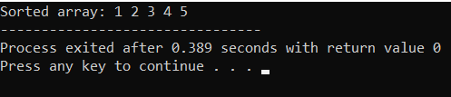

Task no 2:
#include <iostream>
using namespace std;

int main() {
int arr[] = {5, 2, 4, 1, 3};
int n = 5;

cout << "Array before sorting: ";
for (int i = 0; i < n; i++) {
cout << arr[i] << " ";
}

for (int i = 1; i < n; i++) {
int key = arr[i];
int j = i - 1;

while (j >= 0 && arr[j] > key) {
arr[j + 1] = arr[j];
j--;
}

arr[j + 1] = key;
}

cout << "\nArray after sorting: ";
for (int i = 0; i < n; i++) {
cout << arr[i] << " ";
}

return 0;
}

Output:
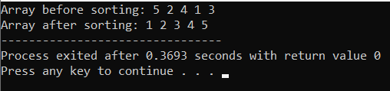

Task no 3:
#include <iostream>
using namespace std;

int main() {
int arr[] = {1, 3, 4, 2, 5};
int n = 5;

cout << "Array before sorting: ";
for (int i = 0; i < n; i++) {
cout << arr[i] << " ";
}

for (int i = 0; i < n - 1; i++) {
int minIndex = i;

for (int j = i + 1; j < n; j++) {
if (arr[j] < arr[minIndex]) {
minIndex = j;
}
}

int temp = arr[i];
arr[i] = arr[minIndex];
arr[minIndex] = temp;
}

cout << "\nArray after sorting: ";
for (int i = 0; i < n; i++) {
cout << arr[i] << " ";
}

return 0;
}

Output:
